Overview
- The Student Experience Model (SEM) promotes systematic processes to ensure consistent student services and increase student retention.
- Orientation is designed to assist students in determining their goals for enrollment in the program. All students receive an orientation that takes place at a time other than during instructional time.
- The Aspire Portfolio System is a purposeful collection of student work and administrative information based on student goals and standards-based education.
- Instruction brings adult students’ real-world knowledge and needs (e.g., home, work, community) together with academic skills (e.g., reading, writing, math, critical thinking, listening, speaking).
- Student follow up supports students in successfully achieving their goals
- In the delivery of services to meet the program’s goals, the program must provide instruction that:
  - integrates the Indicators of Program Quality (IPQs)
  - is based on research principles of adult learning
  - uses student-centered, holistic approaches to teaching
Additionally, programs must strive to provide professional development opportunities for their staff that meet both the programmatic and individual needs for professional growth.

Student Experience Model (SEM)
ohiohighered.org/aspire/reference -> Accountability –> Student Experience Model (SEM)

Retention is crucial to student success; therefore, it is imperative that programs incorporate structure, evidence-based strategies, and practices that encourage student motivation, persistence, and achievement.

The graphic of the Student Experience Model shows the elements of the model as separate and distinct. However, based on the variety of student needs and Aspire program services available, some of these elements may overlap or blend together.

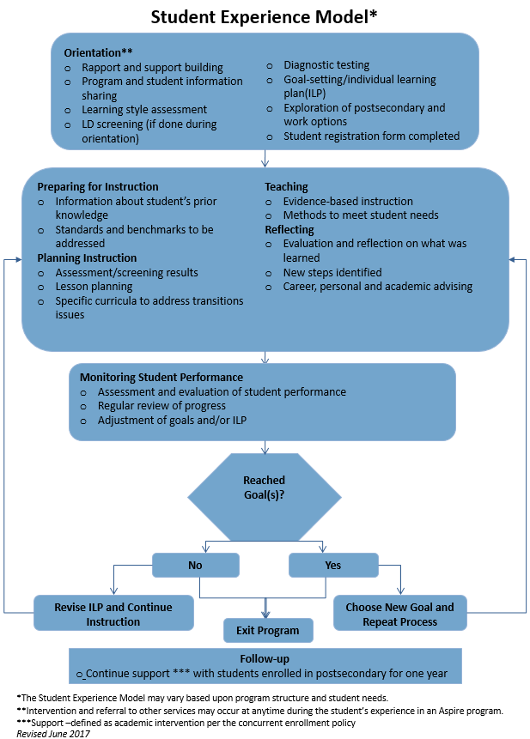

The SEM is based on student retention research. The framework was developed to help local programs serve Aspire students effectively. It is designed to:
- promote the development of systematic processes, procedures, and program components that enhance the quality of literacy services and increase student retention
- help local programs meet standards, benchmarks, and accountability requirements
SEM features:
- The SEM represents good practices employed by Aspire programs.
- It delineates the sequence of events that students encounter as they go through the educational process.
- The SEM may vary based upon program structure and student needs.
- Intervention and referral to other services may occur at any time during students’ experiences in Aspire programs.
- Support is defined to be academic intervention per the concurrent enrollment policy.

Guidance on the Workplace Education Model can be found under the heading Supporting Documents at ohiohighered.org/aspire/ reference. This model may be followed for Aspire programs offered at worksites, especially when services have been customized to meet employers’ needs. If Aspire programs choose not to use the Workplace Education Model, the SEM or the modified SEM must be followed.

Orientation

Orientation Purpose
The purpose of orientation is to ensure that all prospective students are provided with the information and assistance they need to make informed decisions about their participation in Aspire. Some individuals may have been away from the educational process for a long time, so orientation is a way to reintroduce the learning process and acquaint participants with Aspire in Ohio.
Orientation Features
- Orientation is required for all persons interested in participating in an Aspire program.
- All Aspire-funded programs are expected to implement a formal, separate student orientation that includes the required activities detailed on the following pages.
- Orientation is facilitated by qualified, knowledgeable Aspire staff.
- Orientation is offered at regularly-scheduled intervals to support managed enrollment.
- The length of orientation is determined by individual programs.

Required Orientation Activities
Local Aspire programs may determine the order of required orientation activities and programs may find it beneficial to combine some of the activities. However, all programs’ orientations must include the following required activities:
Rapport and Support Building — This includes activities (e.g., icebreakers, motivational films, student success stories, group activities, mini- lessons) that help the student build confidence, feel comfortable, establish relationships, identify support systems, and increase levels of trust and motivation.
Program and Student Information Sharing — Program staff and the student exchange information, so the student may make an informed decision about participation in an Aspire program. This includes:
- program information — oral and written information about the program’s goals, services, structure, delivery, organization, policies, procedures, schedules, referral and support services, the instructor’s role, and the program’s expectations of students
- student information — student contact information (i.e., name, address, telephone number, and student Social Security number) and other demographic data
- assessment, the Portfolio System, and the standards and benchmarks – it is important to introduce these items to students during orientation, so they may be aware of the ways in which learning will be assessed, monitored, and documented. (For more information, see the Assessment section of this guide.)
Learning Style Inventory — An inventory is to be administered that identifies the student’s preferred style of processing information.
NOTE: For special populations such as ESOL or cognitively disabled students, it may be more appropriate to administer the inventory at a time other than orientation. The program may choose the learning style inventory it wants to use.
Initial Goal-setting Instruction — This includes basic instruction on how to set goals. (See the Goal- setting portion of this section for further information.)

Initial Assessment — Programs should administer instruments for the purpose of determining the student’s estimated skill level and the appropriate diagnostic testing level for the entering student. The results of the locator/initial assessment should not be used to determine the subject area in which the student should be tracked. (See the Assessment Policy under the heading Policies at ohiohighered.org/aspire/reference for exceptions and further information.)

LD Screening - Some programs may choose to conduct a screening for possible learning disabilities during orientation if the program’s Learning Disabilities Policy and Planning Guide calls for screening all students. More information about screening options appears in the LD Policy and Planning Guide. (See the LD Policy and Planning Guide under the heading Policies at ohiohighered.org/aspire/reference.)

Exploration of postsecondary and work options - This is an opportunity to build awareness of postsecondary and work options, especially those that students have direct access to through the program. Programs may choose to have students register on ohiomeansjobs.com during orientation. NOTE, while Aspire students are encouraged to register on ohiomeansjobs.com, it may not be appropriate for all students, such as low-level ESOL students.

Student registration form completion - Student forms, such as registration, release of information (RIF), and special needs if applicable, must be completed as the final step of orientation. See RIF and Registration under the heading Forms at ohiohighered.org/aspire/reference.

Optional orientation activities
Based on the objective, focus of the program, program structure, student demographics, and other factors, programs may choose to expand orientation by adding additional topics or activities. Suggestions include:
- aptitude tests
- high school equivalency testing information
- learning disabilities screenings
- vision and hearing screenings
- values identification and prioritization
- language acquisition principles
- listening skills strategies
- multiple intelligence surveys
- career needs assessments
- additional diagnostic assessments
- problem-solving strategies
- reading comprehension strategies
- skills and interests inventories
- workplace assessments
- study and test-taking strategies
- time management techniques

Registration and Enrollment

Registration
ohiohighered.org/aspire/reference -> Forms
Students are registered once they have made informed decisions to participate in Aspire programs -- usually at the end of orientations — and completed Student Registration Forms.
- Programs may choose to separate registration from the orientation process or include registration as the last orientation activity.
- All students must have completed Student Registration Form, which includes the Special Needs Screening
  - Note: Most of the LD screening instruments are not appropriate for the non-native English speaking population, and therefore, should not be administered to ESOL students. The Ohio Department of Higher Education State Aspire Program is not requiring or recommending that LD screenings be used with ESOL students at this time.
- Talking through students’ goals and understanding his/her purpose for registering is an important part of process.

Enrollment
Enrollment means that a student has received a minimum of 12 hours of service in an Aspire program. The student is called a participant. Until an individual has received 12 hours of service, he or she is considered a reportable individual rather than a participant. Only enrolled students/participants are counted in the Annual Performance Report (APR).

Release of Information Form (RIF) and Revocation of Release of Information Form (R-RIF)
ohiohighered.org/aspire/reference -> Forms
A signed RIF is required to share information about students for data match purposes. Service to students is not contingent upon their signing RIFs.
- At the time of registration, students must be informed of follow-up procedures, including use of Social Security numbers to determine attainment of employment, high school diplomas or equivalencies, or postsecondary education. At this time, students should be asked to complete RIFs. Program staff should explain to students the importance of this form for reporting
- Students under the age of 18 must have the signature of a parent or guardian.
- Students who previously signed RIFs but wish to revoke them must complete R-RIFs.
- All RIFs and R-RIFs must be maintained in a locked location at your program site. The forms can be found at ohiohighered.org/aspire/reference, under the heading Forms.

Goal Setting and Individual Learning Plan (ILP) Development
Overview
- Goal setting must take place during orientation and after the completion of the diagnostic assessment.
- All students must have goals recorded as a part of the individual learning plan.
- Student goals may be modified anytime during a program year.
- Each student must have an individual learning plan.

Initial Goal Setting
Goal setting is one of the most important procedures of any learning experience. This ongoing process begins during orientation, extends into the creation of the student’s individual learning plan, and continues throughout instruction as the student progresses. Initial goal-setting instruction helps prospective students begin the process of setting their own goals and making informed decisions about participation in Aspire programs. Program staff should explain the benefits and basic components of goal setting and the action steps involved. Goal setting may be offered individually or in a group setting. A chart illustrating the Goal-setting Process can be found on the following pages.

Introducing Goal Setting
What is a goal and goal setting?
- A goal is something that a person wants to learn, do, have, or be.
- Goal setting involves defining and prioritizing choices and deciding how to get from the beginning to the end.
- Effective goals are specific, measurable, achievable, relevant, and time bound.
What are the benefits of goal setting to the student?
- Defining goals helps a student take action.
- Student benefits of goal setting include realized achievement, improved performance, enhanced self-confidence and self-esteem, and increased motivation and persistence.
What are the supports and barriers to goal achievement?
- A support network (e.g., family, friends, work and business contacts, support groups, professional counselors) may help in achieving goals. Students need to identify the support networks in their lives and recognize how support can help them overcome barriers.
- Certain factors in life may hinder the achievement of goals. Students need to identify those factors in their lives that are potential barriers to goal achievement and prepare themselves to deal with those factors.

Types of goals
To make goal setting more manageable, it is important to break down large goals into smaller goals that can be achieved in shorter periods of time. Goals may be divided into long-term, short- term, and immediate goals.
Long-term goals:
- are major and overarching
- provide general targets to aim toward
- may be distant
- may extend beyond the program year (one year to five years)

Short-term goals:
- are smaller goals that support the long-term goals
- may be prerequisites for eventual achievement of long-term goals
- may be achieved in a relatively short period of time (one month to three months)
Immediate goals:
- have a narrower focus than short-term goals
- may combine actions and specific activities
- may contribute to the achievement of short- term goals
- should be frequently monitored to determine progress or level completion
- may be completed in a short period of time (three weeks to four weeks)
- should include steps or processes to provide students a clear path to completing immediate goals

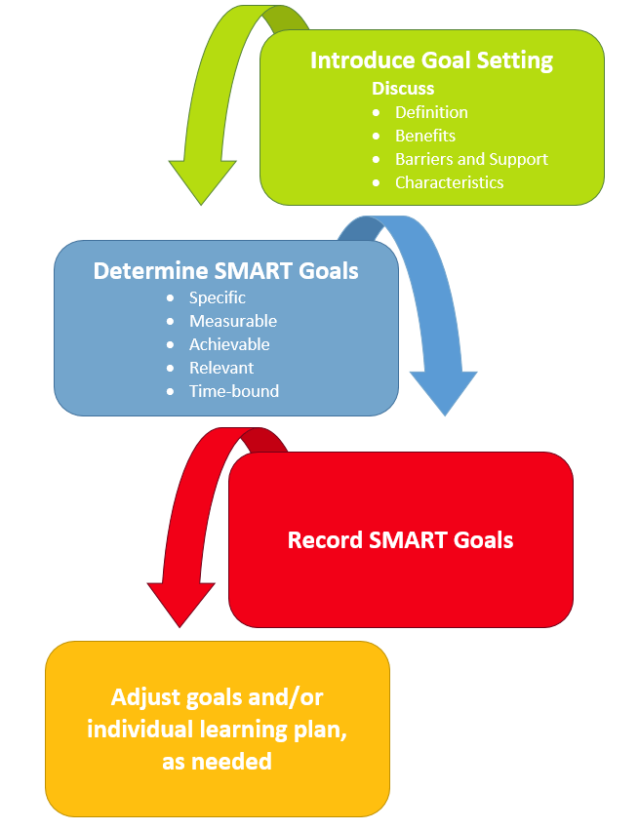

Student implications are:
- If students have a clear vision of where they are going and the steps they will take to get there, they will be motivated to stay in the program.
- Goals provide long-term vision and short- term motivation by helping students measure progress or the levels of completion and take pride in their achievements.
Program implications are:
- Program performance is assessed by evaluating students’ achievements
- Success in meeting program objectives may be increased by helping students set realistic goals that are achievable within the program year.

Identifying Students’ Personal Goals
This part of the goal-setting process provides an opportunity to help students translate their personal goals into goals that can be achieved through Aspire.
- Determine students’ long-term goals. — Based on the initial goal-setting instruction on long-term goals, program staff should help students determine their major, overarching goals. (See the preceding discussion of long- term goals.)
- Explain program and community services.— Program staff should inform students of available services and discuss how the services may help the students reach their long-term goals.
- Establish students’ goals. — Program staff should help the students identify goals and explain how they will be measured and documented. The goals should be established after diagnostic testing has occurred.
- All students should identify goals from those listed on the Student Registration Form. Goals should be achieved during the program year.

Recording Students’ Goals
Each Aspire student’s long- and short-term goals must be recorded on his or her ILP. If the program chooses to use a goal form, it should include space for: student name, program name, orientation site (if different from program name), date, long-term goal, and short-term goal.

Individual Learning Plan (ILP) Development

What Is an Individual Learning Plan?
An Individual Learning Plan is a road map for the student and instructor to help the student reach his or her educational goals during the learning process. It reflects the immediate strategies, steps, and activities the student will employ to reach his or her goals.
Other names for Individual Learning Plans may include Career Education Plan (CEP); Individual Career and Academic Plan (ICAP); or Personal Learning Plan (PLP).

Features
- Each Aspire program must have an individual learning plan for every one of its student.
- Each Aspire program may develop its own individual learning plan format. The individual learning plan must include the required items, listed below.

Process
The instructor and student work together to create the student’s ILP. When doing so they:
- discuss the importance of the process (i.e., planning, implementation, monitoring progress or level completion)
- discuss the roles of the instructor and student in the process
- designate the time frame in which to review goal progress and achievement
- record strategy information

Required Content
- student name
- orientation site (if different from the program site)
- short-term goals and activities and timeline for achieving them
- information about needed adaptations and accommodations, if applicable
- teacher name
- date form is completed
- results of learning style inventory comments section
- program name, long-term goals, student work
- Student goals established in a one on one setting.

See the discussion of long-term, short-term, and immediate goals on the previous pages before recording information in the individual learning plan.

Refer to the Goal-setting and Resources later in this section for further information.

Additional Contents
The individual plan may be one form or several. In addition to identifying information, the plan includes goals and the steps and activities to accomplish them. Goals should be realistic and broken down to a level where they can be obtained within a relatively short period. The student’s plan should be developed in consideration of the student’s educational functioning level, any content of particular importance to the student (e.g., specific career field goals, completing job applications, passing the citizenship test), learning techniques or strategies that would improve the student’s performance as a learner, social skills that would help the student communicate and work with others, and methods of self-advocacy to assist the learner to articulate his or her rights and needs.
Standardized tests, diagnostic assessments, inventories, and screenings provide much information related to the student’s basic skill strengths and weaknesses, learning strategy needs, instructional adaptations, and accommodations that may assist the student in the learning process. Discussions with the student when developing the plan will provide content areas of interest as well as social and self-advocacy needs.
The individual learning plan is not a static document and should be updated as needed during the course of the student’s instructional time with the program. A time frame for meeting the immediate goal(s) and making comments (e.g., indication of whether the goal is met, explanation of why the goal is not met, date of reviews, revisions) are necessary.

Benefits of an individual learning plan
The plan is used to guide instruction. It:
- puts the student at the center of his or her learning plan
- requires that the student be an active partner in his or her learning process
- is tied directly to what happens in the learning process
- provides positive direction for goals
- improves program consistency across Aspire programs
- encourages frequent monitoring of progress toward goals
- is clearly written and understandable by the student and instructor
- responds to the unique and diverse needs of the adult student

Monitoring Student Performance
Overview
- Student progress monitoring must occur at least every 90 days.
- Level completion and advancement are demonstrated by results on a standardized posttest.
- Progress monitoring primarily involves review of the student’s portfolio. When appropriate, standardized testing may also be a part of progress monitoring if the student has received an adequate number of hours of instruction or there is evidence indicating the likelihood that the student has advanced a level.
- Monitoring results, including any test information, must be recorded on the Student Progress Form and entered into ABLELink regularly.

Purpose and Features of Monitoring Student Performance
Student performance is monitored to provide:
- the student with ongoing feedback about his or her performance
- the instructor insight into the effectiveness of the instructional plan so areas can be adjusted as needed
- the program with current student information for the maintenance and updating of information in ABLELink

Monitoring Features
A formal review of each student’s performance is required at least every 90 calendar days starting from the date of registration. Each student’s standardized test information must be recorded on the Student Progress Form and entered into ABLELink. The Monitoring Student Performance table provides an overview of the activities involved in monitoring student performance. The Aspire standards and benchmarks support materials and portfolio information can be found under the Standards and Benchmarks headings at ohiohighered.org/aspire/reference.

Completing the Student Progress Form
ohiohighered.org/aspire/reference -> Forms
The Student Progress Form must be updated as needed to include progress assessment data. The form lists the assessments approved by the state Aspire office. This form may be modified to meet specific program needs. However, the basic content elements must be retained. The following pages include explanations regarding the completion of pertinent sections.

Monitoring Student Performance
Tools | Details

Standards and Benchmarks | - Collect evidence that reflects students’ progress toward and mastery of the standards and benchmarks.  - Alter instructional strategies and materials to help students in mastering standards and benchmarks as needed.  - Plan instruction for benchmarks in every standard, so students do not miss an application skill that would increase their likelihood for success in the next EFLs.
Portfolio Review | - Determine if the student has demonstrated subject area mastery as documented through: standards/benchmarks level completion, curriculum-provided assessments (including in-class or distance software), and/or teacher- or program-developed assessments.  - Review achievements according to the baseline information used for placement (first portfolio review).  - Use the level of performance identified in the last review as a baseline against which to measure progress and determine the appropriateness of administering standardized tests.
Assessment | - Administer standardized assessments per guidelines appearing in the Ohio Aspire Assessment Policy under the heading Policies at ohiohighered.org/aspire/reference.  - Use a variety of assessment measures, including diagnostic, formative, and summative, to gather student performance data.  - Review assessment data to help in making decisions about changing resources, targeting or adjusting instruction, refocusing student efforts, and determining when to posttest with a standardized instrument.  - Maintain and document specific hours of attendance between assessment and progress testing for all students, and make the hours available for review by Aspire program managers. This data must also be entered into ABLELink regularly.
Goal Review | - Use formal and informal methods of evaluating student goals. If the student is making progress toward their short-term goals, he or she should continue working on the goals.  - If the short-term goals have been met, new ones should be set and recorded.  - If the review reveals that the student has met his or her long-term goal and is ready to exit the program, complete an Exit Form as directed.  - If the student wishes to choose another long-term goal, revisit the goal-setting process, and complete a new goal form and ILP.
Individual Learning Plan  - Informal Review  - Formal Review | - Using the above monitoring tools, review the individual learning plan on a regular basis and make adjustments to the plan as needed.  - Informal, possibly unscheduled, reviews offer a “snapshot” of the student’s progress and allow more opportunity for decision making about his or her individual learning plan.  - Using the above monitoring tools, formally review the individual learning plan at least every 90 calendar days, and make adjustments to the plan as needed.

Exiting Students
Overview
- All enrolled students must have completed Student Exit Forms when they exit their programs.
- Aspire programs use the Detailed or Total Attendance feature in ABLELink. The Total Hours field on the Exit Form is calculated from the information programs entered into ABLELink.
- Data should be entered and updated by the 10th of the following month.

Exit quarter is the quarter when one or both of the following occur:
- Instruction ends.
- The student has not received instruction for 90 calendar days and is not scheduled to receive further instruction

Procedures for Exiting Students
A student exits the program when either:
- instruction ends
- he or she has not received instruction for 90 calendar days and is not scheduled to receive further instruction

Exiting Features
- The exit date for individuals with 90 days of non-attendance is the last date of attendance for each student. Programs should wait until the 90 days of non-attendance have passed before setting the exit date in the system unless circumstances justify exiting a student sooner.
- Each enrolled student must have a completed Student Exit Form.
- Student exit data must be entered into ABLELink.

Completing the Student Exit Form
This section provides some additional guidance on completing the Student Exit Form under the heading Forms at ohiohighered.org/aspire/reference.

Follow Up
Overview
- Follow-up information for obtaining high school equivalency, employment, and transitioning into postsecondary education or training is obtained through state-level data matching.
- Only data-matching information is used to determine attainment of the high school equivalency.
- Programs may continue to report follow-up information through the Follow-up Survey if a student has entered postsecondary instruction or obtained employment not covered in data matching.

Data Matching
To comply with the WIOA and the NRS, Ohio is required to collect information relative to the Core Indicators of Performance after students exit Aspire programs. State and local Aspire programs must be consistent in their methods of collection and reporting data to ensure the comparability, reliability, and validity of the information.

State Data Matches Conducted
Type of Data Match | Reasons for Collecting Information
HSE  The state Aspire program has an interagency agreement with the ODE to conduct a data match for HSE information. | - To help students earn HSE or secondary school diploma  - Programs receive all student data from the data match, including test forms, individual test scores, and pass/fail indicators.
ODJFS  The state Aspire program has established an interagency agreement to access employment- related information from the ODJFS. | - To help students obtain a job or retain a current job  - Programs receive quarters employed from the data matching.
Ohio Department of Higher Education  The state Aspire program has an interagency agreement with the ODHE to conduct a match for postsecondary enrollment data. | - To help students enter postsecondary education or training  - Programs receive student-specific information, including year/term enrolled and school/campus information.
NOTE: Only state-level data match information will be accepted as evidence of high school equivalency obtainment.

Follow-Up Surveys
ohiohighered.org/aspire/reference -> Surveys -> Student Follow-up Supplemental Wage/PSET
Programs should use the Follow-up Survey to collect data for students who enter postsecondary training and education in agencies and institutions or whose employers are not covered by the data match. Surveys and the list of students for whom follow-up is done must be kept on file.

The NRS includes exit-based outcome measures for students including employment, earning a high school equivalency, and entering post-secondary education or training.

Use an ABLELink data query to determine students who have exited and review data match information. Follow-up surveys should be sent to students whose employment or postsecondary transition were not included in data match results.

